**Name: Qianzi Xu (Rachel)**

**CMSC110 Introduction to Computing  
Assignment#1 (Due on Tuesday, September 16, 2014)**

**Description and Thoughts**

Figure 1: Pembroke West (West is Best!)

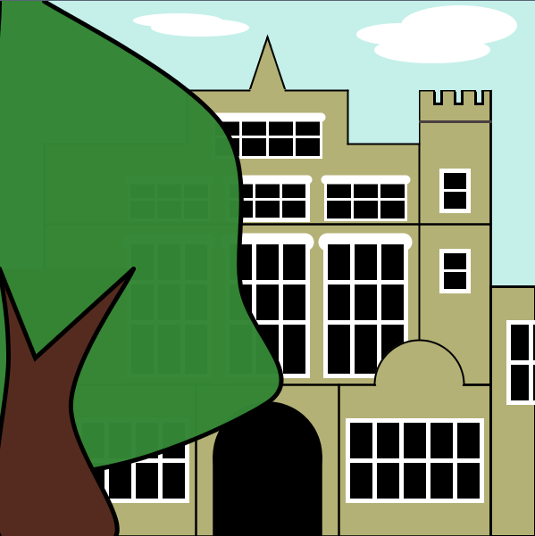

**[Insert your Image here]**

**[Write a short paragraph about your sketch, the program, and what you learned.]**

**The idea of creating an image of my dorm (Pem West) came when I was looking through my photo album. Since I love my dorm so much and the shape of the building can be simplified to be regular and symmetric (and there’s actually a tree that hides Pem East from view), I decided to draw it.**

**It didn’t seem complicated at first sight, but actually it requires a lot of efforts to keep everything in proper positions. I drew a sketch on paper and marked several crucial points with their coordinates. Then I set up the basic structure of building with Processing. I drew a big square on the canvas and established the frame of the building with black lines (some of the black lines were commented out after I’ve finish drawing the windows because there were only used as indicators of positions). After this, I began to draw the windows. Most of the windows are standard size (width 30px, height 45px), which made the calculation of coordinates much easier and saved me lots of time. Finally I carved out the shape of the top of the building on the big square and put a tree in front of Pem East using curves.**

**What I learned from this assignment was that, before starting to draw on the canvas, I should make a careful plan of the whole structure of picture and if possible, making notes during the process of drawing. Comments were really helpful since they made it convenient to refer to a certain block of code, without causing much confusion (as it’s easy to get confused with a bunch of numbers). Specifying a standard measure (e.g. color) helped, too, since I didn’t have to look for a certain RGB value among hundreds of lines over and over again. Moreover, beginShape() and endShape() functions were quite useful especially when I was trying to clear the leftover figures, lines, points (or fuzzy edges) etc. from the picture.**